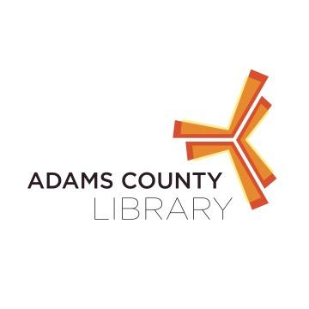

* April 21st- Learn About Simple Machines
* May 19th- Make a Stop Motion Video
* June 16th-Learn About Motors
* July 21st- Learn about Coding
* August 18th- Recap what we’ve learned all summer with stop motion videos, motors, and simple machines

Kids age 4-9 are invited to join us at the New Oxford Area Library for a Saturday Afternoon of fun STEAM activities.

Events occur on the third Saturday of every month from 10:30-11:30 AM

**S.T.E.A.M. Saturdays at New Oxford Area Library**