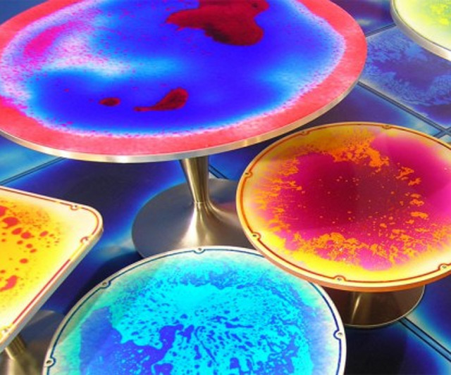

## Experiment with color and create magical mixtures!

## Biglerville Mayor and art teacher Christine Ecker will lead the group through a series of experiments that combine science and art.

## Participants will make lava lamp bottles, create art with skittles, and conduct color changing experiments.

## Please register at the checkout desk or at www.adamslibrary.org

# Magical Mixtures with the Mayor

# Monday, December 2nd from 3-4 pm

# For ages 7 to 11

www.adamslibrary.org