

**Sushi Symphony Program at New Oxford Area Library**

Join Kat for an afternoon of Sushi making!

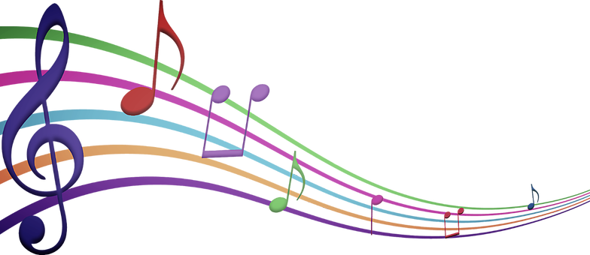

When: August 2nd @ 2:00 PM

Where: New Oxford Area Library

122 N. Peter Street, New Oxford PA

Who: Children

For questions contact the library at 717-624-2182

