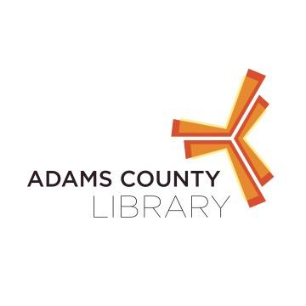

**Kindermusik Program at New Oxford Area Library**

Kindermusik was founded on the principle of empowering children through music. This 40 minute music program will allow babies and toddlers to explore different skills such as gross and fine motor skills, social skills, and listening all while being introduced to some cool musical instruments, singing and dancing.

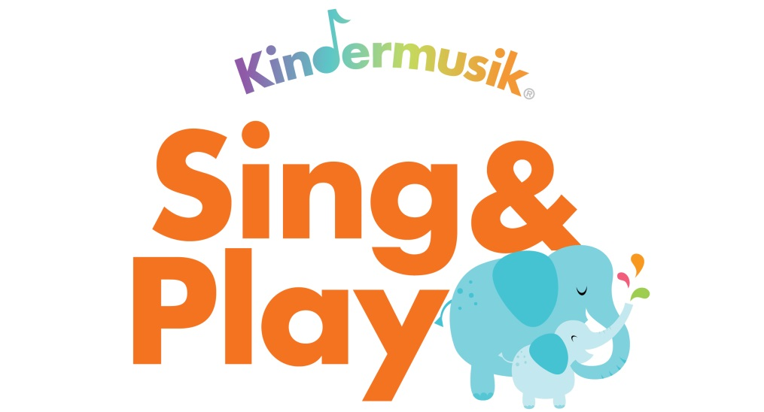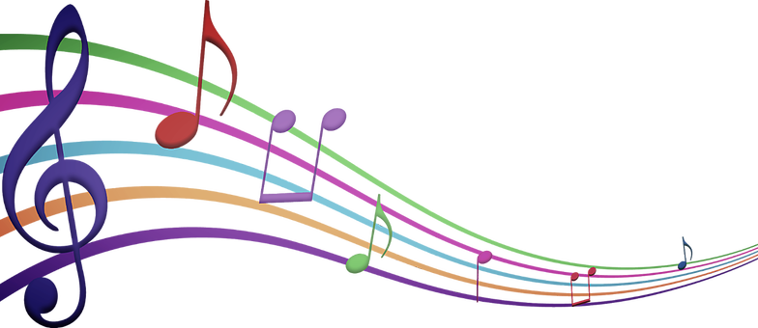

When: June 23rd @ 10:30 AM

Where: New Oxford Area Library

122 N. Peter Street, New Oxford PA

Who: Babies and Toddlers

For questions contact the library at 717-624-2182