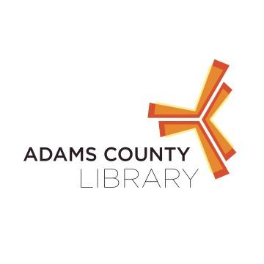

**Beth Rebert Storytelling at New Oxford Area Library**

Beth Rebert will visit New Oxford Area Library to bring *The True Story of the Three Little Pigs* By: Jon Sciesza to life.

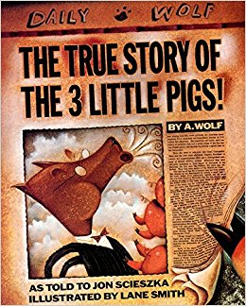

When: June 21st @ 6:30 PM

Where: New Oxford Area Library

122 N. Peter Street, New Oxford PA

Who: Kids of All Ages

For questions contact the library at 717-624-2182